Project 2 Programmer Manual
Steve Walinski
CS221 – November 18th, 2014

1. Problem Description

The program will prompt the user for an input of a number of disks, a starting pole position, and and ending pole position. From here, using an algorithm that recursively calls itself, the program will solve the puzzle while displaying each move to the user in sequence, and with the move numer indicated in the front. The algorithm and program is based on the Towers of Hanoi puzzle.

2. Data Types

2.1 dw:

num – holds the number of disks selected by user

start– holds starting position selected by user

end – holds ending position selected by user

movnum – keeps track of current move number

2.2 db:

Msg1 – Prompts user for number of disks

Msg2 – Prompts user for starting position

Msg3 – Prompts user for ending positon

Er – used to indicate a incorrect input was selected

Msgg1 – prints out name of program

Msgg2 – prints out name of programmer

Msgg3 – prints out date

blankline – used to clear the screen (command prompt)

MovDis - Part of display, works with MovPol1 and MovPol2

MovPol1 – Part of display, same as above.

MovPol2 – Part of display, all together tells user a disk moved from a pole to another pole

3. High Level Program Solution:

3.1 Algorithms:

main program:

1. Initialize ds register to hold data segments.

2. Call subroutine Greet, to print greeting to user.

3. Pushes variable addresses onto the stack.

4. Call subroutine GetNums, to gather input data from user

5. Call subroutine Hanoi to solve the puzzle based on user input

6. End of program.

Greet:

1. Push the registers onto the stack to keep track.

2. Loop; blank: Prints space to clear the command prompt screen, and loops until 25 iterations.

3. Prints program name, name of programmer, and date.

4. Pops the registers, and returns to main program.

GetNums:

1. Push registers onto stack to keep track

2. Prints message asking for user input

3. Gets it, and checks to see if its valid.

4. If not, loops to error and prints message.

5. Prints message asking for user input.

6. See 3 and 4.

7. See 5.

8. Once all data is collected, restore the registers.

9. Returns to main program.

Hanoi:

1. Push registers onto stack to keep track

2. Compares value of num to 1.

3. If it is 1, it jumps to other.

4. Otherwise, it decrements it, finds the unused pole position, and pushes those along with the starting position onto the stack.

5. Recursively calls itself, Hanoi.

6. Increments movnum so that it displays current move number.

7. Displays the movement of the disk to the user.

8. Decrements the number of disk again, pushes it, the unused pole position, and the ending position onto the stack.

9. Recursively calls itself, Hanoi.

10. Jumps to ending.

11. Other: Increments movnum so it displays current move number and displays the movement of the disk to the user.

12. Jumps to ending.

13. Ending: Retores registers from stack.

14. Returns to procedure call while adding 6 to the pointer.

3.2 Design Graph:
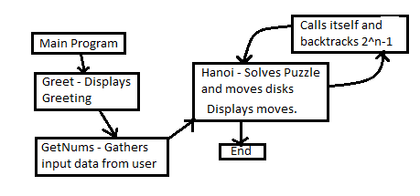

4. Limitations and Suggestions:

a. Clean up the program so that it is more efficient in terms of possibly having lines of code that doesn't necessarily need to be there.

b. Allow the program a way to display all the steps to the user (once more than 4 disks are selected, all the moves cannot be seen) or perhaps a way that each individual step can be displayed at a time.

